Java Web: 实现基本的登录注册
前言
经过几天的忙碌，大致上对java web有了一定了解，尽管走了不少冤路，但还是学到了挺多操作，也不是没有收获。此次，采用JSP, Servlet, JDBC和MySQL实现基本的登录注册功能。
人员分工配合如下：
设计简单的概念以及界面：潘星园
资源素材搜集：史航、赵玉妍
执行检测：王宏远
对各种问题的探讨及解决：李昊泽
目录
1.概要设计 2
1.1资源准备 2
1.2概要设计 2
1.2.1用户模块（图1-2）： 2
1.2.2网页模块（图1-3）： 2
1.3运行环境 3
1.4界面设计（图1-4） 3
2.详细设计 4
2.1初步设计模块（图2-1） 4
2.2写代码前要做的事 4
2.3主要代码 5
2.4连接数据库基本代码 8
3.运行效果 11
3.1初始界面（图3-1） 11
3.2注册界面（图3-2） 11
3.3登录界面 11
3.3.1登陆成功界面（图3-4） 11
3.3.2登录失败界面（图3-5） 12
4.遇到的问题，细化探讨 13
4.1对于JDBCUtils中URL路径问题原因 13
4.2以JDBCUtils为例，关于URL的路径进行探讨 13
4.3在jdbc.properties中存放信息问题 14
附：整体代码如下： 15

1.概要设计

1.1资源准备
搜集书籍以及网上资源，了解java web的框架，通过了解CSDN、百度贴吧等一些贴主对所需的各种功能一些见解和使用方法，加以学会利用整合。对于一些细节把控或者不懂得问题，采取询问，求助等方法。

1.2概要设计
Java web 分为两部分，分别为用户模块和网页模块（图1-1）。
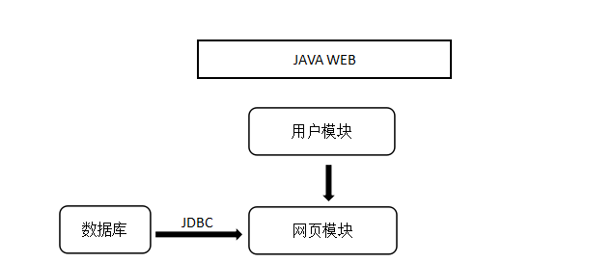
图1-1

1.2.1用户模块（图1-2）：
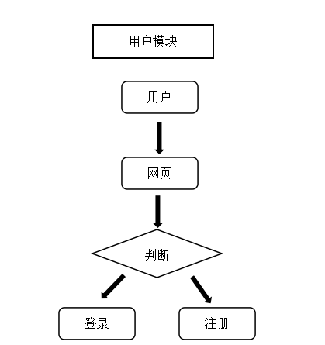
图1-2

1.2.2网页模块（图1-3）：
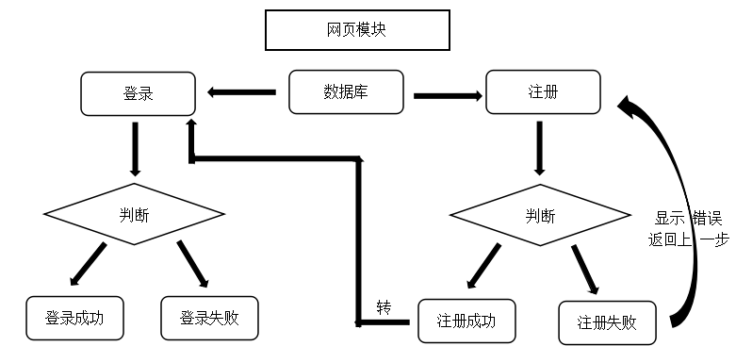
图1-3

1.3运行环境
编译：Myecilpse2017ci、tomcat 8.5
数据库MySQL8.0
连接：mysql-connector-java-5.1.48-bin.jar

1.4界面设计（图1-4）
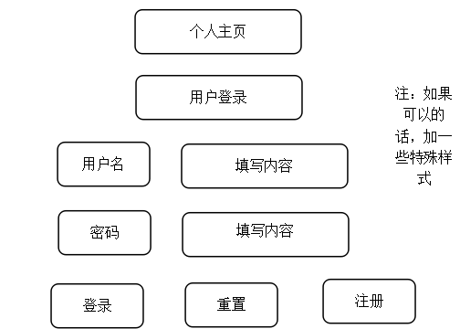
图1-4
对于注册页面，添加一个邮箱，便于联系（图1-5）。
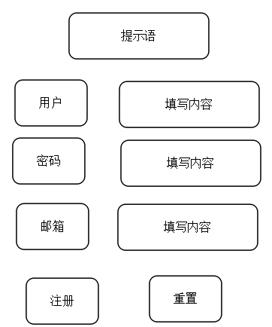
图1-5

2.详细设计

2.1初步设计模块（图2-1）
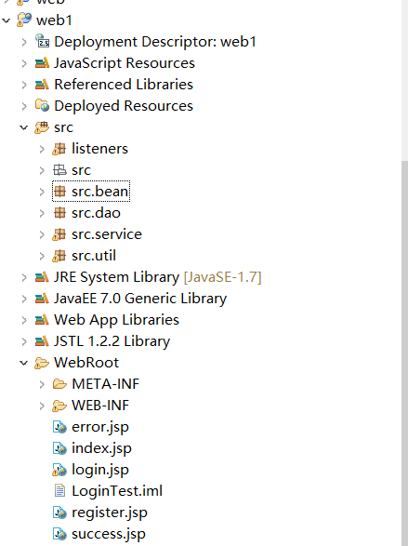
图2-1
其中各包存放功能：
Bean：文件夹用来放自己定义的类，比如这里用到的User来存放用户名，邮箱和密码；
Dao：是数据访问对象(Data Access Object)，用来对数据库进行查询、插入等操作；
Service：里放了两个servlet类，分别对应登录和注册相关操作；
Uti：l放一些当工具用的类，这里的JDBCUtils.java专门用来对数据库进行连接和释放；
Web：下面则是一些jsp页面和web.xml配置文件。

2.2写代码前要做的事
(1)建立数据库，建立用户赋予权限，建立MySQL表user（图2-2）。
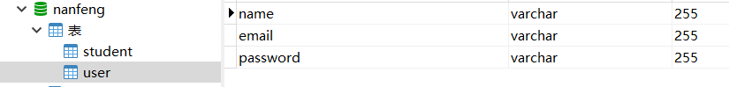
图2-2
(2)在Myecilpse2017ci创建java web项目，并把连接数据库用的mysql-connector-java-5.1.48-bin.jar包添加进项目中（图2-3）。 在tomcat的lib下面也加入mysql-connector-java-5.1.48-bin.jar包，否则运行时会出现java.lang.ClassNotFoundException: com.mysql.jdbc.Driver。
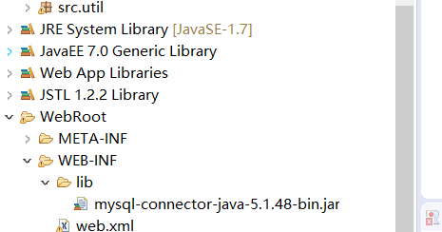
图2-3

2.3主要代码
2.3.1网页登录代码
package src.service;
import src.bean.User;
import src.dao.UserDAO;
import javax.servlet.ServletException;
import javax.servlet.annotation.WebServlet;
import javax.servlet.http.HttpServlet;
import javax.servlet.http.HttpServletRequest;
import javax.servlet.http.HttpServletResponse;
import java.io.IOException;
//@WebServlet(name = "Login",urlPatterns={"LoginServlet"})
@WebServlet(name = "Login",urlPatterns={"/Login.action" })
public class LoginServlet extends HttpServlet {
protected void doPost(HttpServletRequest request, HttpServletResponse response) throws ServletException, IOException {
request.setCharacterEncoding("utf-8");
response.setContentType("text/html;charset=utf-8");
String username = request.getParameter("username");
String password = request.getParameter("password");
UserDAO userDAO = new UserDAO();
User user = userDAO.login(username, password);
if(user != null){
request.getRequestDispatcher("success.jsp").forward(request,response);
} else{
request.getRequestDispatcher("error.jsp").forward(request, response);
}
}
protected void doGet(HttpServletRequest request, HttpServletResponse response) throws ServletException, IOException {
doPost(request, response);
}
}
2.3.2网页注册代码
package src.service;
import src.bean.User;
import src.dao.UserDAO;
import javax.servlet.ServletException;
import javax.servlet.annotation.WebServlet;
import javax.servlet.http.HttpServlet;
import javax.servlet.http.HttpServletRequest;
import javax.servlet.http.HttpServletResponse;
import java.io.IOException;
//@WebServlet(name = "RegisterServlet",urlPatterns={"RegisterServlet"})
@WebServlet(name = "Register", urlPatterns={"/Register.action" })
public class RegisterServlet extends HttpServlet {
protected void doPost(HttpServletRequest request, HttpServletResponse response) throws ServletException, IOException {
request.setCharacterEncoding("utf-8");
response.setContentType("text/html;charset=utf-8");

String name = request.getParameter("name");
String email = request.getParameter("email");
String password = request.getParameter("password");
User user = new User();
user.setName(name);
user.setPassword(password);
user.setEmail(email);
UserDAO userDAO = new UserDAO();
boolean flag = userDAO.register(user);
if(flag){
System.out.println("注册成功");
request.getRequestDispatcher("login.jsp").forward(request,response);
} else{
System.out.println("注册失败");
request.getRequestDispatcher("register.jsp").forward(request,response);
}
}

protected void doGet(HttpServletRequest request, HttpServletResponse response) throws ServletException, IOException {
doPost(request, response);
}
}
2.3.3用户代码（主）
package src.dao;

import src.bean.User;
import src.util.JDBCUtils;

import java.sql.*;

public class UserDAO {

/**
* 登录功能
* @param username
* @param password
* @return 用户对象 User
*/
public User login(String username, String password){
User u = null;
Connection con = null;
Statement sta = null;
ResultSet res = null;
try {
//1.获取连接
con = JDBCUtils.getConnection();
//2.定义sql
String sql = "select * from user where name = '"+username+"' and password = '"+password+"'";
//3.获取执行sql的对象
sta = con.createStatement();
//4.执行查询
res = sta.executeQuery(sql);
//5.判断
if(res.next()){
u = new User();
u.setName(res.getString("name"));
u.setPassword(res.getString("password"));
System.out.println("登录成功");
} else{
System.out.println("用户名或密码错误");
}
} catch (SQLException e) {
e.printStackTrace();
} finally {
JDBCUtils.close(res, sta, con);
}
return u;
}

/**
* 注册功能
* @param user
* @return
*/
public boolean register(User user){
String username= user.getName();
String email = user.getEmail();
String password = user.getPassword();
Connection con = null;
Statement sta = null;
ResultSet res = null;
try {
con = JDBCUtils.getConnection();
sta = con.createStatement();

//判断输入是否合法
if(username.length()==0 || password.length()==0){
return false;
}

//判断用户名是否已存在
String querySql = "select * from user where name = '"+username+"'";
res = sta.executeQuery(querySql);
if(res.next()){
System.out.println("用户名已存在！");
return false;
}

//添加新用户
String insertSql = "insert into user (name,email,password) values " +
"('"+username+"','"+email+"','"+password+"')";
sta.executeUpdate(insertSql);

} catch (SQLException e) {
e.printStackTrace();
} finally {
JDBCUtils.close(res, sta, con);
}
return true;
}
}

2.4连接数据库基本代码
package src.util;
import java.io.FileInputStream;
import java.io.FileReader;
import java.io.IOException;
import java.net.URL;
import java.sql.*;
import java.util.Properties;
public class JDBCUtils {
public static String url;
private static String user;
private static String password;
private static String dirver;
public static void load(){
//static{
//读取资源文件，获取值
try {
//1.创建properties集合类
Properties pro = new Properties();
//FileInputStream iFile = new FileInputStream("C:\\Users\\hzs\\Desktop\\web2\\src\\src\\jdbc.properties");
FileInputStream iFile = new FileInputStream("D:\\Workspaces\\MyEclipse 2017 CI\\web1\\src\\src\\jdbc.properties");
pro.clear();
pro.load(iFile);
iFile.close();

url = pro.getProperty("url");
System.out.println("################### " + url);
user = pro.getProperty("user");
password = pro.getProperty("password");
dirver = pro.getProperty("driver");
//5.注册驱动
Class.forName(dirver);
} catch (IOException | ClassNotFoundException e) {
e.printStackTrace();
}
}

/**
* 获取连接
* @return 连接对象
*/
public static Connection getConnection() throws SQLException {
return DriverManager.getConnection(url, user, password);
}

/**
* 释放资源
* @param ress
* @param stat
* @param conn
*/
public static void close(ResultSet ress, Statement stat, Connection conn){
if(ress != null){
try {
ress.close();
} catch (SQLException e) {
e.printStackTrace();
}
}
if(stat != null){
try {
stat.close();
} catch (SQLException e) {
e.printStackTrace();
}
}
if(conn != null){
try {
conn.close();
} catch (SQLException e) {
e.printStackTrace();
}
}
}

public static void close(Statement stat, Connection conn){
if(stat != null){
try {
stat.close();
} catch (SQLException e) {
e.printStackTrace();
}
}
if(conn != null){
try {
conn.close();
} catch (SQLException e) {
e.printStackTrace();
}}}}

3.运行效果

3.1初始界面（图3-1）
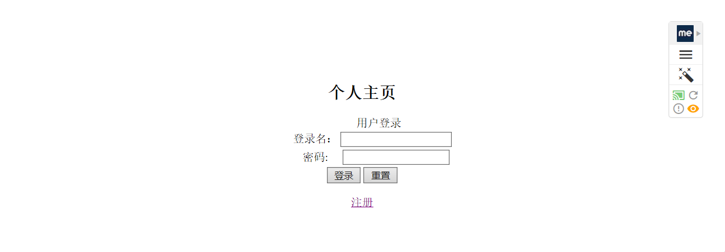
图3-1

3.2注册界面（图3-2）
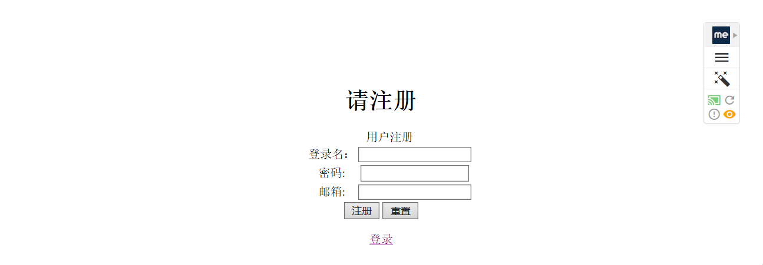
图3-2
3.2.1注册成功界面（图3-3）
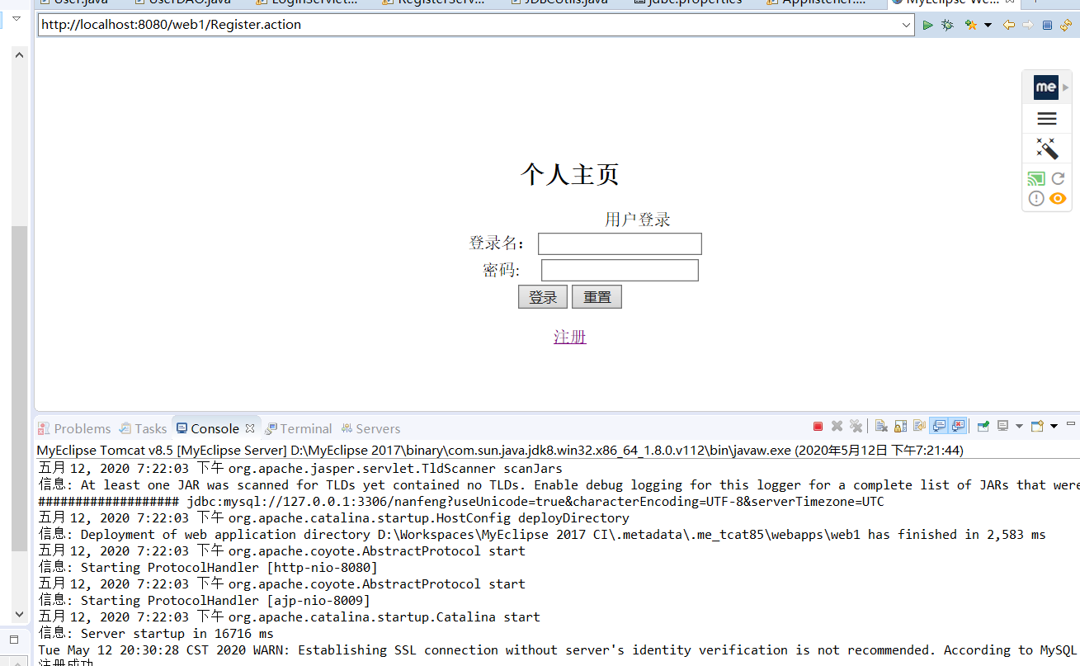
（图3-3）

3.3登录界面

3.3.1登陆成功界面（图3-4）
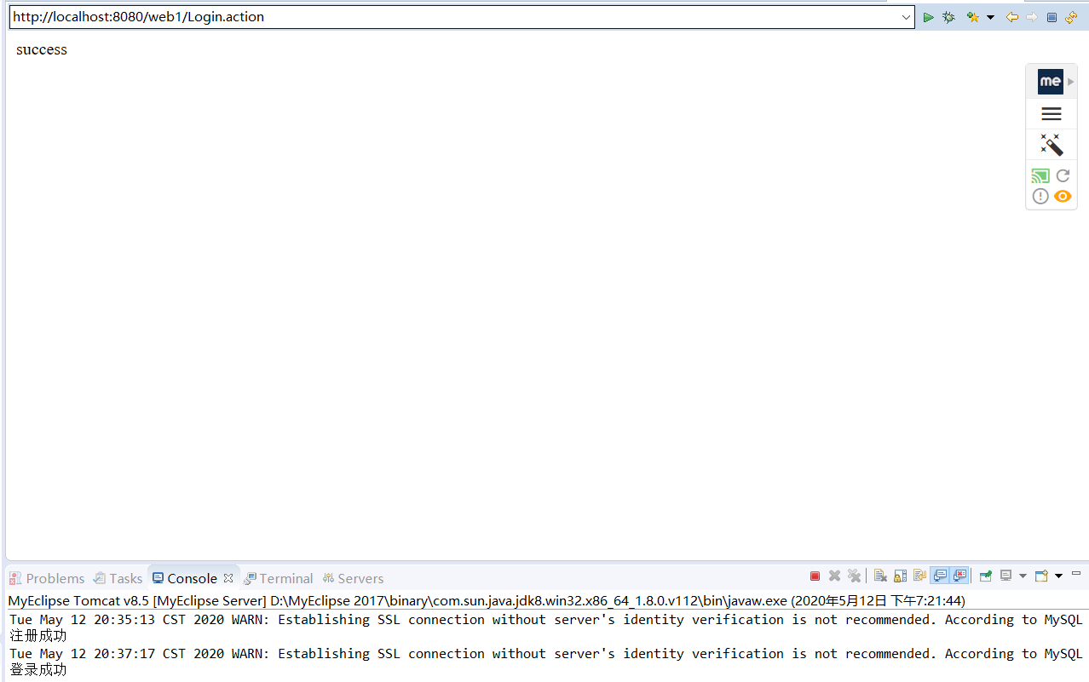
图3-4

3.3.2登录失败界面（图3-5）
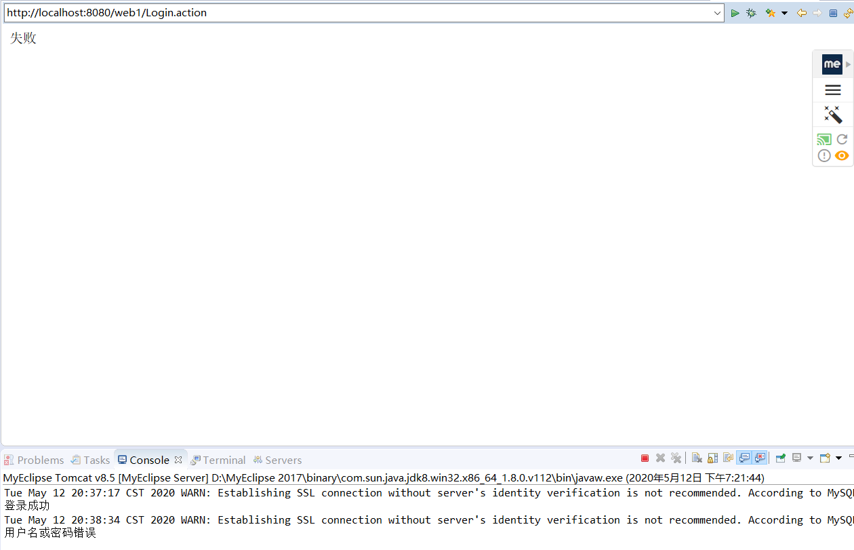
图3-5

4.遇到的问题，细化探讨

4.1对于JDBCUtils中URL路径问题原因
DAO是数据访问对象，在对数据库进行读写操作前需要先创建数据库的连接，操作结束也要释放相关资源。猜测项目发展后面可能会对数据库里不同的表进行不同的操作，如果在每个dao文件里都写一遍连接和释放的方法不仅非常麻烦，致命的一点是如果有改动比如数据库名或者url之类，就必须每个类里都得改一遍，也容易出错。所以单独写出一个工具出来专门做这个。
此外，读取资源文件的时候会用到一些信息比如MySQL的用户名和密码 ，还有数据库对应的url，这些信息为了方便统一管理，可以把它们放到一个properties文件中。

4.2以JDBCUtils为例，关于URL的路径进行探讨
4.2.1对于JDBCUtils中URL，方法一：路径锁死
代码如下：
public static void load(){
//static{
//读取资源文件，获取值
try {
//1.创建properties集合类
Properties pro = new Properties();
//FileInputStream iFile = new
FileInputStream iFile = new FileInputStream("properties所在路径");
pro.clear();
pro.load(iFile);
iFile.close();

url = pro.getProperty("url");
System.out.println("################### " + url);
user = pro.getProperty("user");
password = pro.getProperty("password");
dirver = pro.getProperty("driver");
4.2.2对于JDBCUtils中URL，方法二：路径不锁死
代码如下：
public static void load(){
//static{
//读取资源文件，获取值
try {
//打出来 System.getProperty("catalina.base")路径，然后把 jdbc.properties
//这个文件放到该路径下。
System.out.println("=catalina.base路径 " + System.getProperty("catalina.base"));
Properties pro = new Properties();
FileInputStream iFile = new FileInputStream(System.getProperty("catalina.base") + "jdbc.properties");
pro.clear();
pro.load(iFile);
iFile.close();
url = pro.getProperty("url");
user = pro.getProperty("user");
password = pro.getProperty("password");
dirver = pro.getProperty("driver");

4.2.3对于JDBCUtils中URL，方法三：通过Applistener查找HOME，存放properties
public static void load(String home){
//static{
// 从Applistener的 contextInitialized传来应用所在位置的路径
try {
// 打印出home的位置，然后把jdbc.properties文件放到这个目录下
System.out.println("=================== " + home);

Properties pro = new Properties();
FileInputStream iFile = new FileInputStream(home + "jdbc.properties");
pro.clear();
pro.load(iFile);
iFile.close();

url = pro.getProperty("url");

user = pro.getProperty("user");
password = pro.getProperty("password");
dirver = pro.getProperty("driver");

4.3在jdbc.properties中存放信息问题
里面包含名字、数据库连接用户名、密码、URL、驱动图（4-1）。
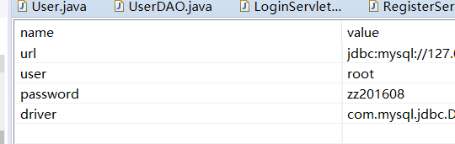
图4-1
须确保，信息无误，对于com.mysql.jdbc.Driver需与所对应的jdbc.jar版本保持一致。

附：整体代码如下：
Applistener.java类（监听类）
package listeners;
import javax.servlet.ServletContextEvent;
import javax.servlet.ServletContextListener;
import javax.servlet.annotation.WebListener;

import src.util.JDBCUtils;

@WebListener
public class Applistener implements ServletContextListener {
@Override
public void contextDestroyed(ServletContextEvent e) {
}
@Override
public void contextInitialized(ServletContextEvent e) {
//e.getServletContext().setAttribute("onLineCount", 0);
// e.getServletContext().setAttribute("maxOnLineCount", 0);
String path = e.getServletContext().getRealPath("/");

JDBCUtils.load();
}
}

User.java类
package src.bean;

public class User {
private int id;
private String name;
private String email;
private String password;

public User(){
super();
}

public int getId(){
return id;
}
public void setId(int id){
this.id = id;
}

public String getName(){
return name;
}
public void setName(String name){
this.name = name;
}

public String getEmail(){
return email;
}
public void setEmail(String email){
this.email = email;
}

public String getPassword(){
return password;
}
public void setPassword(String password){
this.password = password;
}

}

UserDAO.java类
package src.dao;

import src.bean.User;
import src.util.JDBCUtils;

import java.sql.*;

public class UserDAO {

/**
* 登录功能
* @param username
* @param password
* @return 用户对象 User
*/
public User login(String username, String password){
User u = null;
Connection con = null;
Statement sta = null;
ResultSet res = null;
try {
//1.获取连接
con = JDBCUtils.getConnection();
//2.定义sql
String sql = "select * from user where name = '"+username+"' and password = '"+password+"'";
//3.获取执行sql的对象
sta = con.createStatement();
//4.执行查询
res = sta.executeQuery(sql);
//5.判断
if(res.next()){
u = new User();
u.setName(res.getString("name"));
u.setPassword(res.getString("password"));
System.out.println("登录成功");
} else{
System.out.println("用户名或密码错误");
}
} catch (SQLException e) {
e.printStackTrace();
} finally {
JDBCUtils.close(res, sta, con);
}
return u;
}

/**
* 注册功能
* @param user
* @return
*/
public boolean register(User user){
String username= user.getName();
String email = user.getEmail();
String password = user.getPassword();
Connection con = null;
Statement sta = null;
ResultSet res = null;
try {
con = JDBCUtils.getConnection();
sta = con.createStatement();

//判断输入是否合法
if(username.length()==0 || password.length()==0){
return false;
}

//判断用户名是否已存在
String querySql = "select * from user where name = '"+username+"'";
res = sta.executeQuery(querySql);
if(res.next()){
System.out.println("用户名已存在！");
return false;
}

//添加新用户
String insertSql = "insert into user (name,email,password) values " +
"('"+username+"','"+email+"','"+password+"')";
sta.executeUpdate(insertSql);

} catch (SQLException e) {
e.printStackTrace();
} finally {
JDBCUtils.close(res, sta, con);
}
return true;
}
}

LoginServlet.java类
package src.service;

import src.bean.User;
import src.dao.UserDAO;

import javax.servlet.ServletException;
import javax.servlet.annotation.WebServlet;
import javax.servlet.http.HttpServlet;
import javax.servlet.http.HttpServletRequest;
import javax.servlet.http.HttpServletResponse;
import java.io.IOException;

//@WebServlet(name = "Login",urlPatterns={"LoginServlet"})
@WebServlet(name = "Login",urlPatterns={"/Login.action" })
public class LoginServlet extends HttpServlet {
protected void doPost(HttpServletRequest request, HttpServletResponse response) throws ServletException, IOException {
request.setCharacterEncoding("utf-8");
response.setContentType("text/html;charset=utf-8");
String username = request.getParameter("username");
String password = request.getParameter("password");
UserDAO userDAO = new UserDAO();
User user = userDAO.login(username, password);
if(user != null){
request.getRequestDispatcher("success.jsp").forward(request,response);
} else{
request.getRequestDispatcher("error.jsp").forward(request, response);
}
}

protected void doGet(HttpServletRequest request, HttpServletResponse response) throws ServletException, IOException {
doPost(request, response);
}
}

RegisterServlet.java类
package src.service;

import src.bean.User;
import src.dao.UserDAO;

import javax.servlet.ServletException;
import javax.servlet.annotation.WebServlet;
import javax.servlet.http.HttpServlet;
import javax.servlet.http.HttpServletRequest;
import javax.servlet.http.HttpServletResponse;
import java.io.IOException;

//@WebServlet(name = "RegisterServlet",urlPatterns={"RegisterServlet"})
@WebServlet(name = "Register", urlPatterns={"/Register.action" })
public class RegisterServlet extends HttpServlet {
protected void doPost(HttpServletRequest request, HttpServletResponse response) throws ServletException, IOException {
request.setCharacterEncoding("utf-8");
response.setContentType("text/html;charset=utf-8");

String name = request.getParameter("name");
String email = request.getParameter("email");
String password = request.getParameter("password");
User user = new User();
user.setName(name);
user.setPassword(password);
user.setEmail(email);
UserDAO userDAO = new UserDAO();
boolean flag = userDAO.register(user);
if(flag){
System.out.println("注册成功");
request.getRequestDispatcher("login.jsp").forward(request,response);
} else{
System.out.println("注册失败");
request.getRequestDispatcher("register.jsp").forward(request,response);
}
}

protected void doGet(HttpServletRequest request, HttpServletResponse response) throws ServletException, IOException {
doPost(request, response);
}
}

JDBCUtils.java类
package src.util;

import java.io.FileInputStream;
import java.io.FileReader;
import java.io.IOException;
import java.net.URL;
import java.sql.*;
import java.util.Properties;

public class JDBCUtils {
public static String url;
private static String user;
private static String password;
private static String dirver;

public static void load(){
//static{
//读取资源文件，获取值
try {
//1.创建properties集合类
Properties pro = new Properties();
//FileInputStream iFile = new FileInputStream("C:\\Users\\hzs\\Desktop\\web2\\src\\src\\jdbc.properties");
FileInputStream iFile = new FileInputStream("D:\\Workspaces\\MyEclipse 2017 CI\\web1\\src\\src\\jdbc.properties");
pro.clear();
pro.load(iFile);
iFile.close();

url = pro.getProperty("url");
System.out.println("################### " + url);
user = pro.getProperty("user");
password = pro.getProperty("password");
dirver = pro.getProperty("driver");
//5.注册驱动
Class.forName(dirver);
} catch (IOException | ClassNotFoundException e) {
e.printStackTrace();
}
}

/**
* 获取连接
* @return 连接对象
*/
public static Connection getConnection() throws SQLException {
return DriverManager.getConnection(url, user, password);
}

/**
* 释放资源
* @param ress
* @param stat
* @param conn
*/
public static void close(ResultSet ress, Statement stat, Connection conn){
if(ress != null){
try {
ress.close();
} catch (SQLException e) {
e.printStackTrace();
}
}
if(stat != null){
try {
stat.close();
} catch (SQLException e) {
e.printStackTrace();
}
}
if(conn != null){
try {
conn.close();
} catch (SQLException e) {
e.printStackTrace();
}
}
}

public static void close(Statement stat, Connection conn){
if(stat != null){
try {
stat.close();
} catch (SQLException e) {
e.printStackTrace();
}
}
if(conn != null){
try {
conn.close();
} catch (SQLException e) {
e.printStackTrace();
}
}
}
}

jdbc.properties
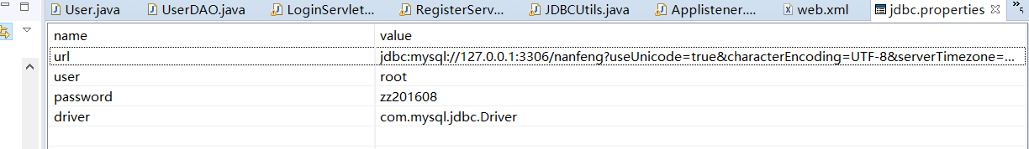

Web.xml
<?xml version="1.0" encoding="UTF-8"?>
<web-app xmlns="http://xmlns.jcp.org/xml/ns/javaee"
xmlns:xsi="http://www.w3.org/2001/XMLSchema-instance"
xsi:schemaLocation="http://xmlns.jcp.org/xml/ns/javaee http://xmlns.jcp.org/xml/ns/javaee/web-app_2.5.xsd"
version="2.5">
<welcome-file-list>
<welcome-file>login.jsp</welcome-file>
<welcome-file>register.jsp</welcome-file>
<welcome-file>success.jsp</welcome-file>
<welcome-file>errir.jsp</welcome-file>
</welcome-file-list>

<servlet>
<!-- 类名 -->
<servlet-name>LoginServlet</servlet-name>
<!-- 所在的包 -->
<servlet-class>service.LoginServlet</servlet-class>
</servlet>
<servlet-mapping>
<servlet-name>LoginServlet</servlet-name>
<!-- 访问的网址 -->
<url-pattern>/LoginServlet</url-pattern>
</servlet-mapping>

<servlet>
<!-- 类名 -->
<servlet-name>RegisterServlet</servlet-name>
<!-- 所在的包 -->
<servlet-class>service.RegisterServlet</servlet-class>
</servlet>
<servlet-mapping>
<servlet-name>RegisterServlet</servlet-name>
<!-- 访问的网址 -->
<url-pattern>/RegisterServlet</url-pattern>
</servlet-mapping>

</web-app>

Error.jsp

<%@ page contentType="text/html;charset=UTF-8" language="java" %>
<html>
<head>
<title>Title</title>
</head>
<body>
失败
</body>
</html>

Login.jsp

<%@ page contentType="text/html;charset=UTF-8" language="java" %>
<!DOCTYPE html PUBLIC "-//W3C//DTD HTML 4.01 Transitional//EN" "http://www.w3.org/TR/html4/loose.dtd">
<html>
<head>
<title>登录界面</title>
</head>
<body>
<div style="text-align:center;margin-top:120px">
<h2>个人主页</h2>

<form action="Login.action" method="post">
<table style="margin-left:40%">
<marquee width="200"scrolldelay="250">用户登录</marquee>

<tr>
<td>登录名：</td>
<td><input name="username" type="text" size="21"></td>
</tr>
<tr>
<td>密码:</td>
<td><input name="password" type="password" size="21"></td>
</tr>
</table>
<input type="submit" value="登录">
<input type="reset" value="重置">
</form>
<br>
<a href="register.jsp">注册</a>
</div>
</body>
</html>
Register.jsp

<%@ page contentType="text/html;charset=UTF-8" language="java" %>
<!DOCTYPE html PUBLIC "-//W3C//DTD HTML 4.01 Transitional//EN" "http://www.w3.org/TR/html4/loose.dtd">
<html>
<head>
<title>注册界面</title>
</head>
<body>
<div style="text-align:center;margin-top:120px">
<h1 >请注册</h1>

<form action="Register.action" method="post">
<table style="margin-left:40%">
<caption>用户注册</caption>
<tr>
<td>登录名：</td>
<td><input name="name" type="text" size="20"></td>
</tr>
<tr>
<td>密码:</td>
<td><input name="password" type="password" size="20"></td>
</tr>
<tr>
<td>邮箱:</td>
<td><input name="email" type="text" size="20"></td>
</tr>
</table>
<input type="submit" value="注册">
<input type="reset" value="重置">
</form>
<br>
<a href="login.jsp">登录</a>
</div>
</body>
</html>

Success.jsp

<%@ page contentType="text/html;charset=UTF-8" language="java" %>
<html>
<head>
<title>Title</title>
</head>
<body>
success。成功
</body>
</html>

